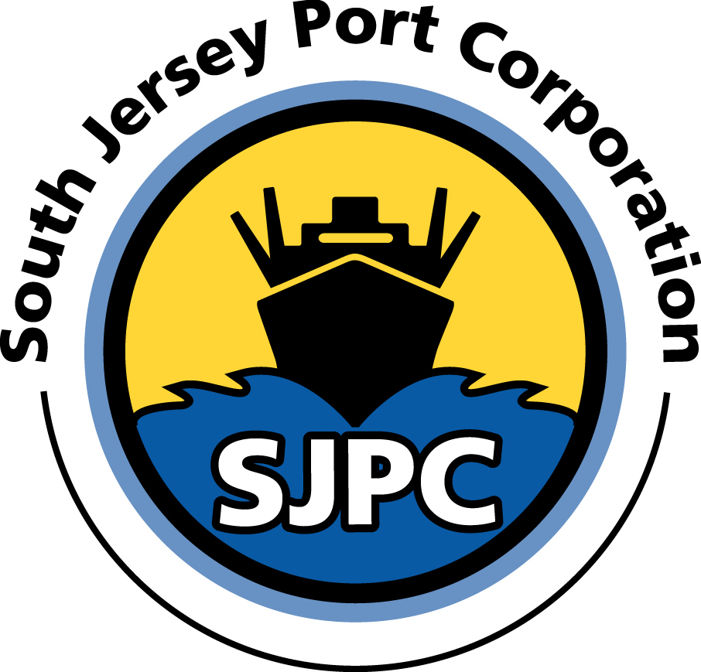

SOUTH JERSEY PORT CORPORATION
OFFICIAL BOARD OF DIRECTORS CLOSED MEETING MINUTES
BROADWAY TERMINAL
CAMDEN, NEW JERSEY
February 3, 2015
1:22 p.m.

Directors Present: | Richard Alaimo | Chairman
 | Chad Bruner | Director
 | Christopher Chianese | State Treas. Designee
 | Robert DeAngelo | Director 
 | Joseph Maressa, Jr. | Director
 | Craig Remington | Director
 | Sheila Roberts | Director
Directors Absent: | Jonathan Gershen | Director
 | Eric Martins | Director
 | Carl Styles | Director
In Attendance: | Tyler Yingling | Governor’s Authorities Unit
 | Fabian Ruiz | Governor’s Authorities Unit
 | Raymond Zane, Esq. | Gen. Counsel – Zane & Lozuke
 | Kevin Castagnola | Executive Director & CEO
 | Jay Jones | Dep. Exec. Dir. / Board Secretary
 | Bruno Cellucci | Treasurer
 | Hank D’Andrea | Facilities Engineer
 | Neil Grossman | Financial Advisor

* Individuals listed in attendance may or may not have been in attendance during the
entire Closed Session, but will be so noted in the text of the minutes.

The following are matters currently under discussion and/or in negotiations and are covered by one or more of the following legal exemptions:

- Matters made confidential by state, federal law or rule by court.
- Disclosure would result in an unwarranted invasion of individual privacy, unless the person affected consents in writing.
- Disclosure would impair the body's right to receive federal or state funds.
- Collective bargaining.
- Lease or acquisition of property, setting of banking rates, investment of public funds if disclosure would harm the public interest.
- Investigations into violations of law.
- Strategies to protect public security.
- Pending, ongoing or anticipated litigation or contract negotiation, including attorney-client privilege. The threat of litigation must be more than theoretical for this exemption to apply.
- Personnel matters affecting employees of the public bodies, unless all parties request or consent to a public hearing. Prior to discussion of personnel, affected employees must be given notice, known as a Rice notice, which gives the employee the right to request a public hearing.
- Proceedings that could result in a suspension, civil penalty, or loss of a license or permit. Details of such negotiations will be made public when closed session is no longer required.

GENERAL COUNSEL’s REPORT
Mr. Raymond Zane, Esq. presented the General Counsel’s report. The report contained brief updates on Holtec Phase II, Holtec ground lease and EPA, Holtec lease amendment, Holt lease amendment, Holt memorandum of understanding, the Terraces property acquisition, Weeks Marine settlement documents review, the Clorox property acquisition for Paulsboro Marine Terminal, the BP assumption and assignment of the ground lease at the Paulsboro Marine Terminal, the change in ownership of the Holcim tenant, Bids review for the Removal and Replacement of Rail Track Project, OPRA request for plan list of the Repair and Replacement of Rail Track bids, review of Conrail lease, and review of Sunoco FTZ agreement and receivable.

There was a discussion about the Holcim being bought by another company and the new company’s decision to sell of the Camden plant because of its proximity with another plant is too close. Staff and counsel will be meeting with the company to ensure the new owner can and will satisfy all the terms and conditions of the lease.

The General Counsel report was received and filed.

BROADWAY TERMINAL SPRINKLER SYSTEM
The Executive Director reported that we still have to address funding for the replacement of the Broadway Terminal sprinkler system.

MAINTENANCE DREDGING

The Executive Director commented we are still working on a funding solution and plan to perform maintenance dredging at our berths. It has been six years since maintenance dredging has been performed. The norm is to conduct dredging every three to four years. The opportunity to use the ACOE’s vendor, Great Lakes, will they a mobilized in the river to save considerable cost, is no longer viable.

PERSONNEL

The Executive Director reported on the office employees joining into a collective bargaining agreement through the Communication Workers of America through two separate units. We are waiting on the negotiations to begin.

BUILDING H2 ROOF

The Executive Director reported that the roof for building H2 leased to Camden International Commodities Terminal needs to be replaced. The initial cost estimate is in the $400,000 range based on a quick evaluation of the roof by S.T. Hudson Engineers. The Chairman recommended that that an Infrared Thermal Imaging Scan needs to be performed for the detection of moisture and water leaks. Staff discussed that we would get proposals from the pre-qualified engineers to prepare specifications for the roof repair or replacement.

The Chairman asked if there was any additional business from Closed Session. Hearing none, he asked for a motion to adjourn Closed Session and enter back into Regular Open Session.

A motion was made to adjourn the Closed Session Meeting.

Moved by: R. DeAngelo
Seconded by: J. Maressa, Jr.

Voting for motion: All
Voting against motion: None

At 1:35 p.m., the Closed Session was adjourned.

I certify that this is a true copy of the Minutes of the South Jersey Port Corporation’s Executive Closed Session of the Board of Director’s meeting held Tuesday, February 3, 2015.

Jay Jones
Board Secretary

